CRICKET PLAYER PERFORMANCE TRACKING
APPLICATION CRICKSTATS

Expanded Student Project Report

Salesforce-Based Application for Player Performance Management

Prepared as a student project document

Technology: Salesforce Lightning • Custom Objects • Flows • Reports & Dashboards
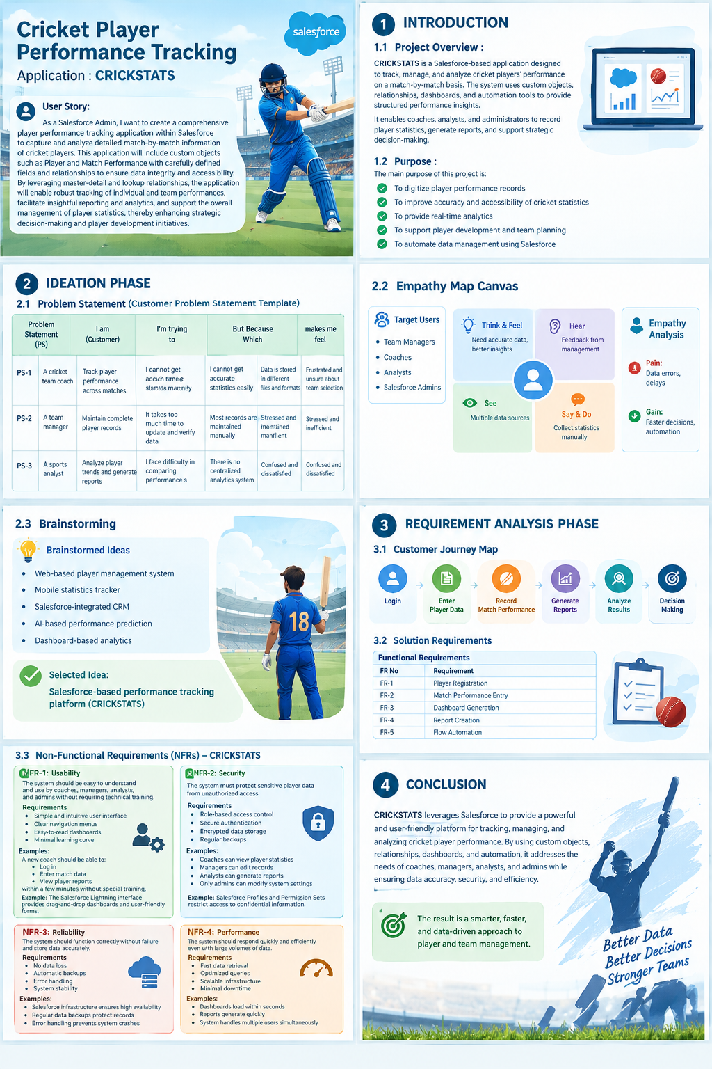

Student Project Declaration
This report presents the development and implementation of CRICKSTATS, a Salesforce-based cricket player performance tracking application. The document expands the original project material into a structured student report covering the problem, requirements, design, implementation, testing, results, advantages, limitations, and future scope.
The project is based on the supplied CRICKSTATS project document and preserves its core terminology, objects, fields, relationships, automation approach, and development milestones.

Abstract
CRICKSTATS is a cloud-based cricket performance tracking application developed on the Salesforce platform. The application is intended to centralize player and match-performance information that would otherwise be maintained manually across different files and formats. It provides custom Player and Match Performance objects, relationships between them, roll-up summaries, a Lightning application, screen flows, reports, and dashboards.
The main objective is to make cricket statistics easier to capture, retrieve, analyze, and report. By bringing match-bymatch information into a structured Salesforce data model, the system can calculate cumulative statistics such as matches played, total runs, fours, sixes, overs, wickets, stumpings, catches, and average score. The project also demonstrates practical use of Salesforce configuration, automation, analytics, SDLC activities, and Agile-style sprint planning.

Keywords
CRICKSTATS, Salesforce, Cricket Analytics, Player Performance, Match Performance, Lightning App, Salesforce Flow, Roll-up Summary, Reports, Dashboards, CRM

Table of Contents
- Introduction
- Ideation Phase
- Requirement Analysis
- Project Design
- Project Planning and Scheduling
- Project Development and Implementation
- Functional and Performance Testing
- Results and Discussion
- Advantages and Disadvantages
- Conclusion
- Future Scope
- Appendix

1. INTRODUCTION

1.1 Project Overview
CRICKSTATS is a Salesforce-based application designed to track, manage, and analyze cricket players’ performance on a match-by-match basis. The original project describes the application as a solution using custom objects, relationships, dashboards, and automation tools to provide structured performance insights.
The application is designed around two central data entities: Player and Match Performance. Player records store relatively stable player information, while Match Performance records capture statistics associated with individual matches. Salesforce relationships connect these records so that cumulative player-level statistics can be derived from match-level data.

1.2 Purpose
- Digitize player performance records.
- Improve accuracy and accessibility of cricket statistics.
- Provide timely analytics and reporting.
- Support player development and team planning.
- Reduce repetitive manual data-management work through Salesforce automation.

1.3 Objectives
- Create a centralized database for player and match information.
- Capture batting, bowling, and fielding statistics in structured fields.
- Use relationships to connect players with their match performances.
- Use roll-up summaries to calculate cumulative statistics.
- Provide a simple Lightning interface for users.
- Use flows to filter and display player information dynamically.
- Support reports and dashboards for analysis and decision-making.

1.4 Target Users
- Team Managers – maintain complete player records and monitor team-level information.
- Coaches – review player performance when planning and evaluating teams.
- Sports Analysts – compare statistics, identify trends, and prepare reports.
- Salesforce Administrators – configure objects, fields, security, automation, and application settings.2. IDEATION
PHASE

2.1 Problem Statement
The project identifies a practical problem in cricket performance management: coaches and managers need matchby-match statistics, but accurate information may be difficult to obtain when records are distributed across different files and formats. Manual maintenance also increases the effort required to update and verify records.
User | Need | Existing Problem | Effect
Team Coach | Track performance across matches | Statistics are not easily available in one place | Uncertainty during team selection
Team Manager | Maintain complete player records | Records are largely maintained manually | Time-consuming updates and  verification
Sports Analyst | Analyze trends and generate reports | Performance comparison is difficult without centralized analytics | Delayed or unclear analysis
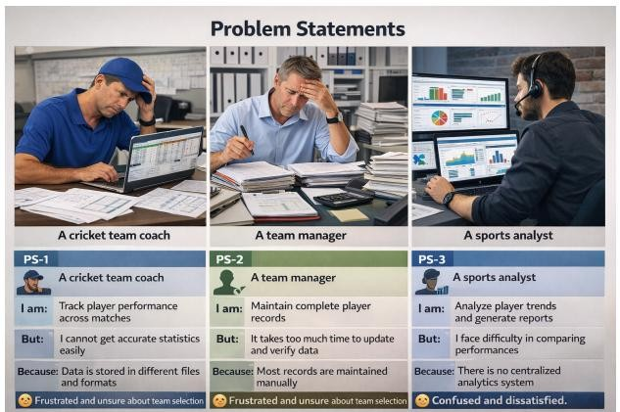

2.2 Empathy Map
- Think & Feel: Need accurate data and better insights.
- Hear: Feedback from management and team stakeholders.
- See: Multiple data sources and manually maintained statistics.
- Say & Do: Collect and update statistics manually.
- Pain: Data errors and delays.
- Gain: Faster decisions and automation.
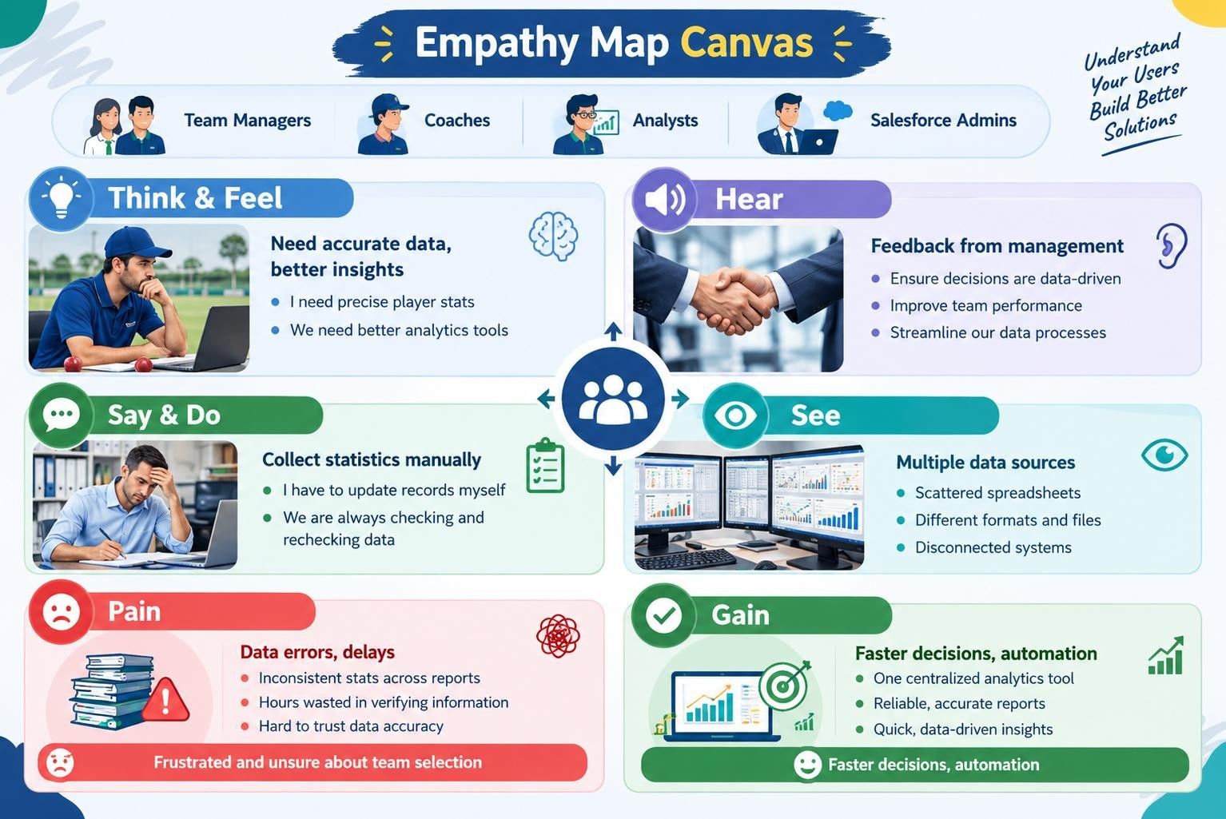

2.3 Brainstorming and Selected Idea
- Web-based player management system.
- Mobile statistics tracker.
- Salesforce-integrated CRM.
- AI-based performance prediction.
- Dashboard-based analytics.
Selected idea: a Salesforce-based performance tracking platform named CRICKSTATS. The selection aligns the project with a structured cloud database, automation, reporting, and dashboard capabilities.
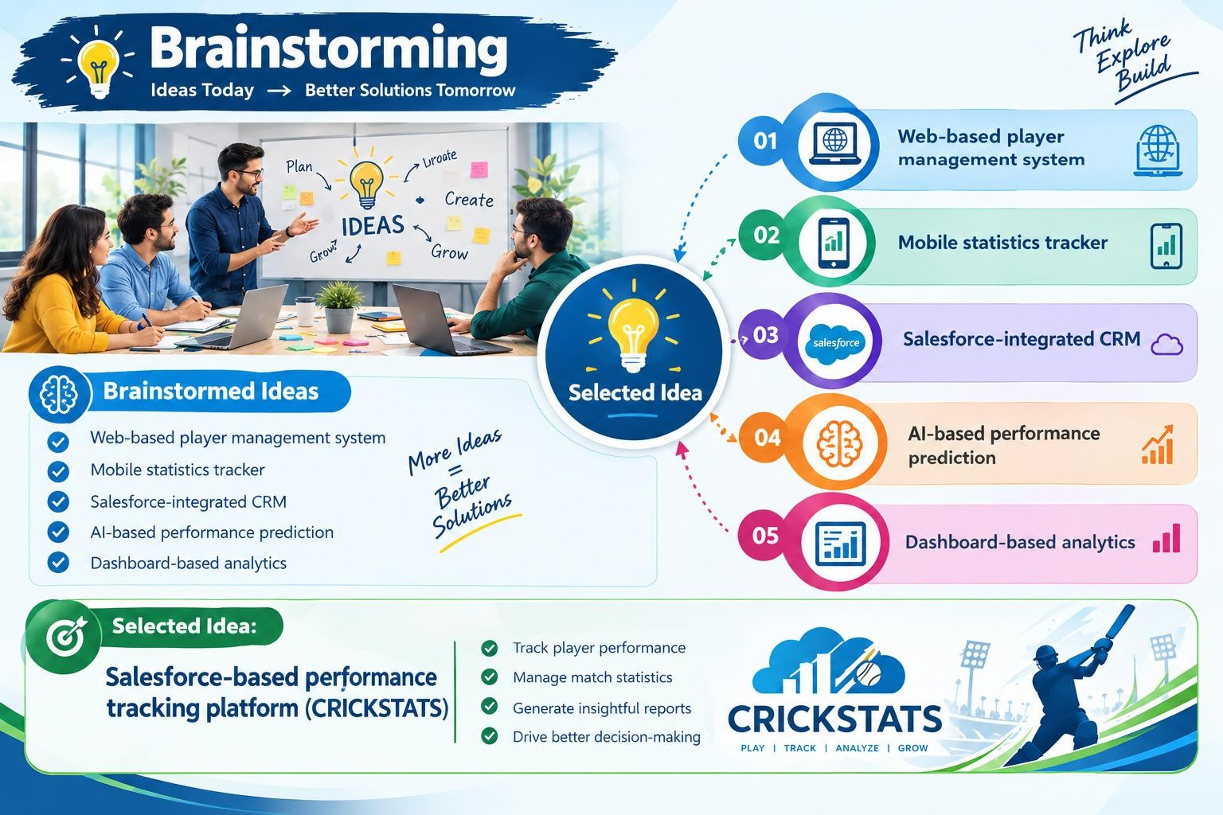

3. REQUIREMENT ANALYSIS

3.1 Customer Journey
The documented customer journey follows a straightforward sequence:
- Login
- Enter Player Data
- Record Match Performance
- Generate Reports
- Analyze Results
- Decision Making.
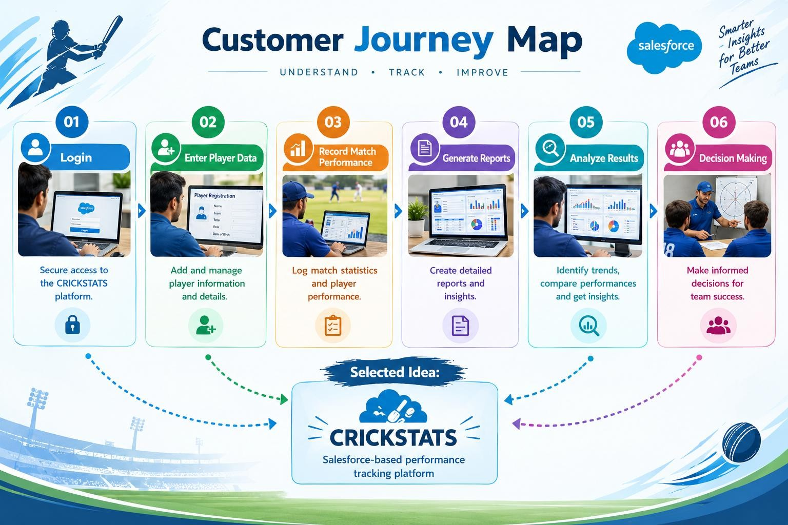

3.2 Functional Requirements
ID | Requirement | Purpose
FR-1 | Player Registration | Create and maintain player records.
FR-2 | Match Performance Entry | Capture match-level statistics.
FR-3 | Dashboard Generation | Present performance information visually.
FR-4 | Report Creation | Generate structured analytical reports.
FR-5 | Flow Automation | Automate data retrieval and user interaction.

3.3 Non-Functional Requirements
Usability: Simple navigation, readable dashboards, and a minimal learning curve.
Security: Role-based access, secure authentication, protected data, and controlled permissions.
Reliability: Accurate storage, error handling, stability, and recovery support.
Performance: Fast page loading, quick report generation, and smooth dashboard rendering.
Availability: Cloud-based access with minimal downtime.
Scalability: Ability to support increasing users, players, teams, leagues, and records.

3.4 Data Flow
The documented data flow is: User → Salesforce UI → Player Object → Match Performance → Reports → Dashboard.
This shows how user input moves into structured Salesforce records and is subsequently transformed into
information for analysis.
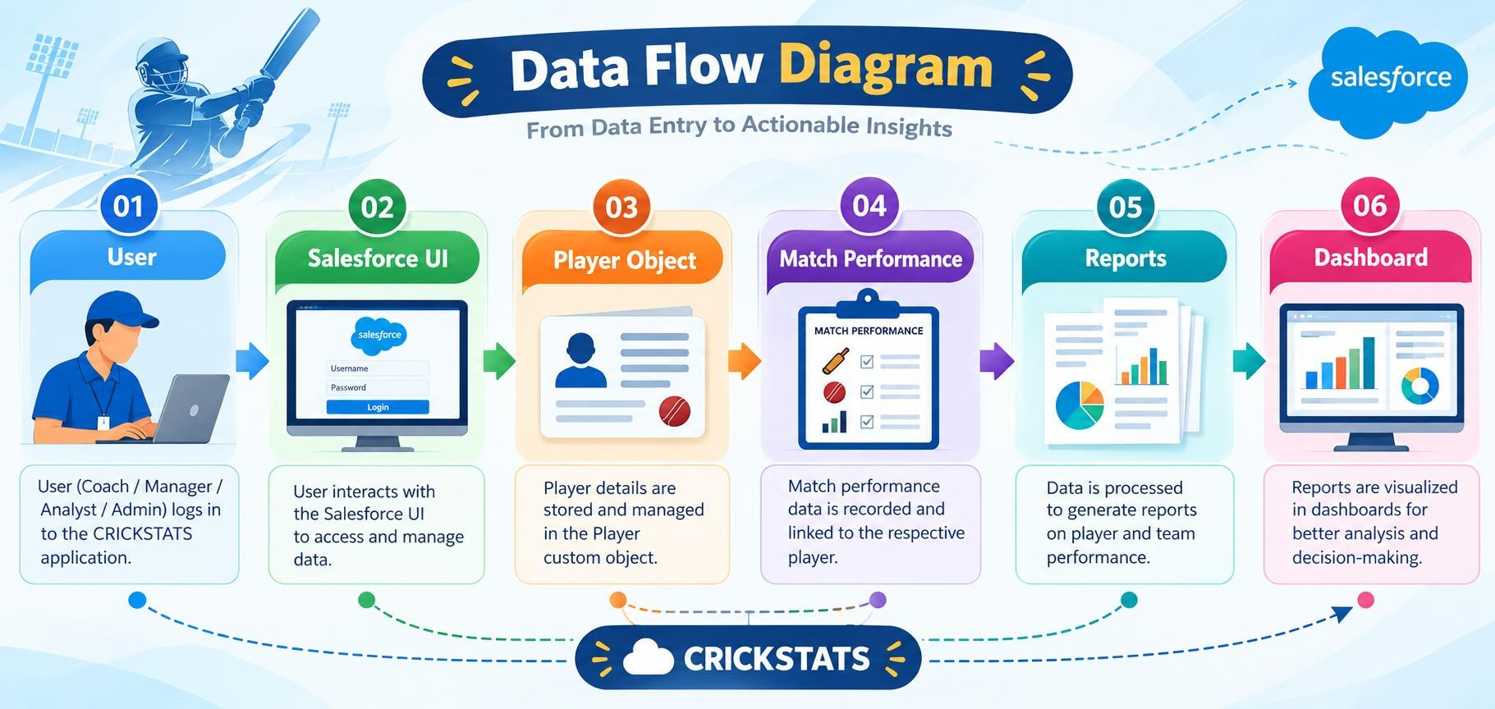

4. PROJECT DESIGN

4.1 Problem–Solution Fit
The project addresses manual and fragmented performance management by introducing a centralized Salesforce system. Manual records are replaced by structured objects; data retrieval is supported through relationships; cumulative statistics are calculated through roll-up summaries; and analysis is supported by reports and dashboards.

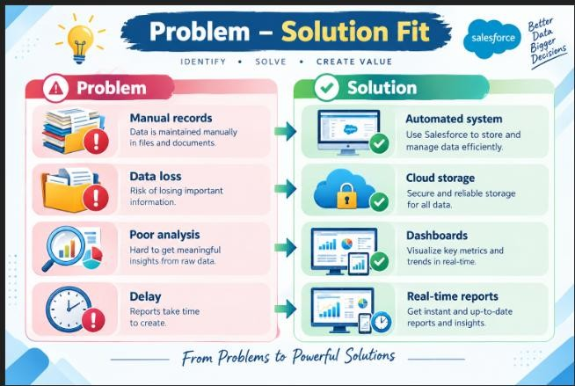

4.2 Proposed Solution
- Custom objects: Player and Match Performance.
- Master-detail and lookup relationships.
- Roll-up summary fields for cumulative statistics.
- CRICKSTATS Lightning application.
- Automated Salesforce flows.
- Interactive reports and dashboards.
- Centralized, cloud-based data storage.
- Secure and scalable access.

4.3 Solution Architecture
Layer | Components
Presentation Layer | Salesforce Lightning UI
Application Layer | Flows and application logic
Data Layer | Player and Match Performance objects
Analytics Layer | Reports and dashboards
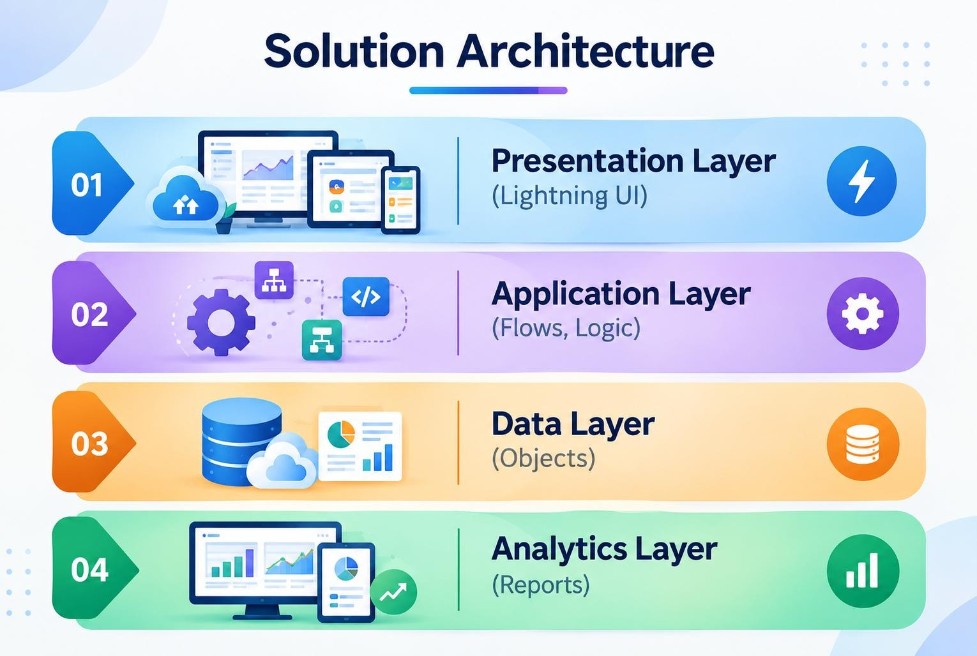
change design in this pic

5. PROJECT PLANNING & SCHEDULING

5.1 Development Approach
The project follows an Agile-oriented execution model. Development is organized into sprints, with the major progression being developer setup, data modeling, navigation and UI, data structure, validation and automation, followed by reporting and testing activities.

5.2 Product Backlog Summary
Sprint | Story | Task | Points | Priority
Sprint-1 | USN-1 | Create Salesforce developer account | 1 | High
Sprint-1 | USN-2 | Create Player and  Match Performance objects | 3 | High
Sprint-2 | USN-3 | Create navigation tabs | 3 | High
Sprint-2 | USN-4 | Create dedicated  CRICKSTATS Lightning  App | 3 | High
Sprint-2 | USN-5 | Create player and match  fields | 5 | Medium
Sprint-2 | USN-6 | Customize page layouts | 5 | High
Sprint-2 | USN-7 | Validate player and match inputs | 3 | High
Sprint-3 | USN-8 | Create automated flows to update statistics | 5 | High

5.3 Sprint Schedule
The source document defines four planned six-day sprints. Sprint-1 is shown as 24 Oct 2022 to 29 Oct 2022, followed by Sprint-2, Sprint-3, and Sprint-4 in one-week increments.

6. PROJECT DEVELOPMENT & IMPLEMENTATION
Project Flow
Milestone 1 : Creation of developer account
Milestone 2 : Object Creation
Milestone 3 : Tabs
Milestone 4 : The Lightning App
Milestone 5 : Fields & Relationships
Milestone 6 : Roll-up Summary
Milestone 7 : Flows

Implementation
Milestone 1 - Salesforce developer account creation :

Activity 1: Creating Developer Account:
Creating a developer org in salesforce.
- Go to https://developer.salesforce.com/signup
- On the sign up form, enter the following details :
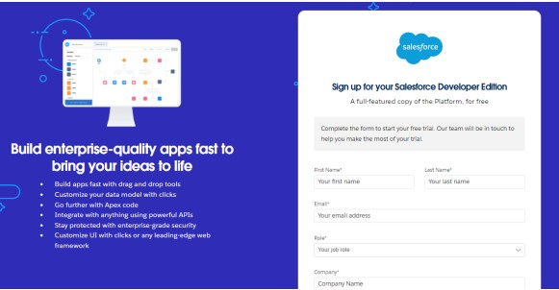
- First name & Last name
- Email
- Role : Developer
- Company : College or Company Name
- County : India
- Postal Code : pin code
- Username : should be a combination of your name and company
This need not be an actual email id, you can give anything in that format : username@organization.com
Click on sign me up after filling these.

Activity 2: Account Activation :
- Go to the inbox of the email that you used while signing up. Click on the verify account to activate your account. The email may take 5-10mins.
- Click on Verify Account
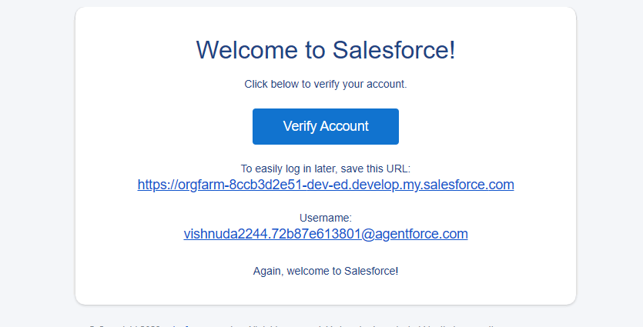
- Give a password and answer a security question and click on change password.
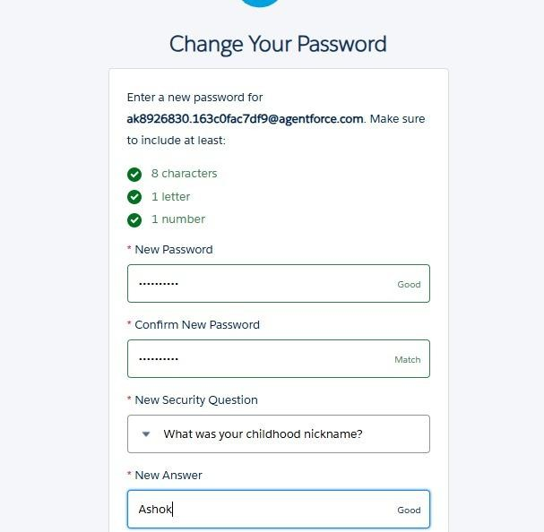
- Then you will redirect to your salesforce setup page.
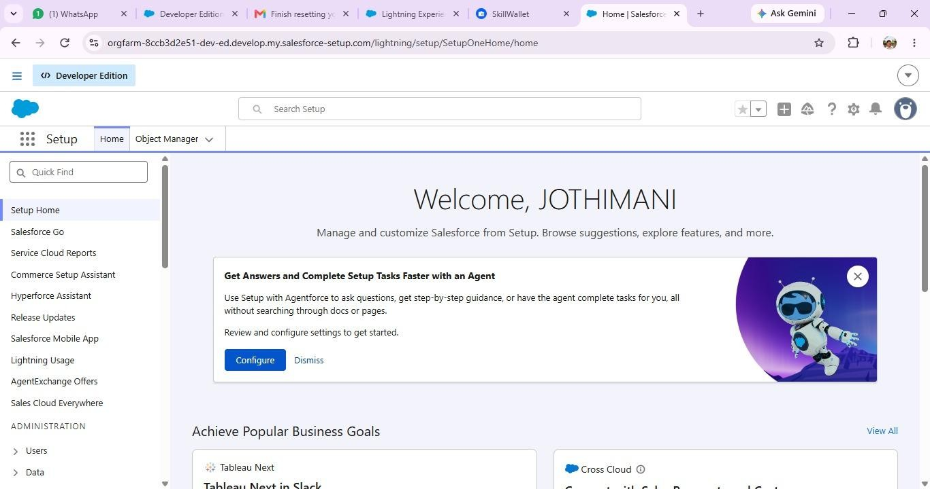

Milestone 2 - Object Creation
Activity 1 : Player Object
  - In your Salesforce org, click gear icon on the top left and select Setup to open setup.
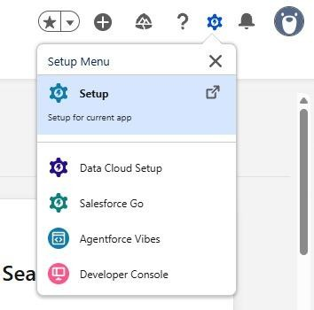
  - Click the Object Manager tab. If you don’t see it, enter Object Manager in the Quick Find box
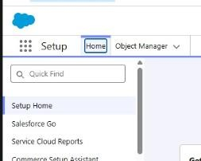

  - On the Object Manager page, click Create | Custom Object.
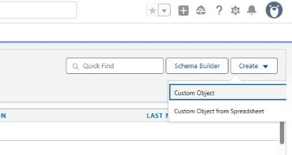
1. From the setup page → Click on Object Manager → Click on Create → Click on Custom Object.
    - Label : Player
    - Plural Label : Players
    - Enter Record Name Label and Format
Record Name : Player Name
Data Type : Text
• In Optional features : check the boxes for Allow Reports | Allow Activities | Track Field History.
    - Search Status : check the box for Allow Search.
    - Save

Activity 2 : Match Performance Object
1. From the setup page → Click on Object Manager → Click on Create → Click on Custom Object.
- Label : Match Performance
- Plural Label : Match Performances
- Enter Record Name Label and Format Record Name : Customer Account Name
Data Type : Text
- In Optional features : check the boxes for Allow Reports | Allow Activities | Track Field History.
- Search Status : check the box for Allow Search.
- Save

Milestone 3 – Tabs Activity 1 : Custom tabs creation

- Go to setup page → type Tabs in Quick Find bar → click on tabs → New (under custom object tab)
- Select Object(Player) → Select the tab style → Next (Add to profiles page) keep it as default → Next (Add to Custom App) uncheck the include tab .
- Make sure that the Append tab to users' existing personal customizations is checked.
- Click save.
- Repeat the same steps for Match Performances.

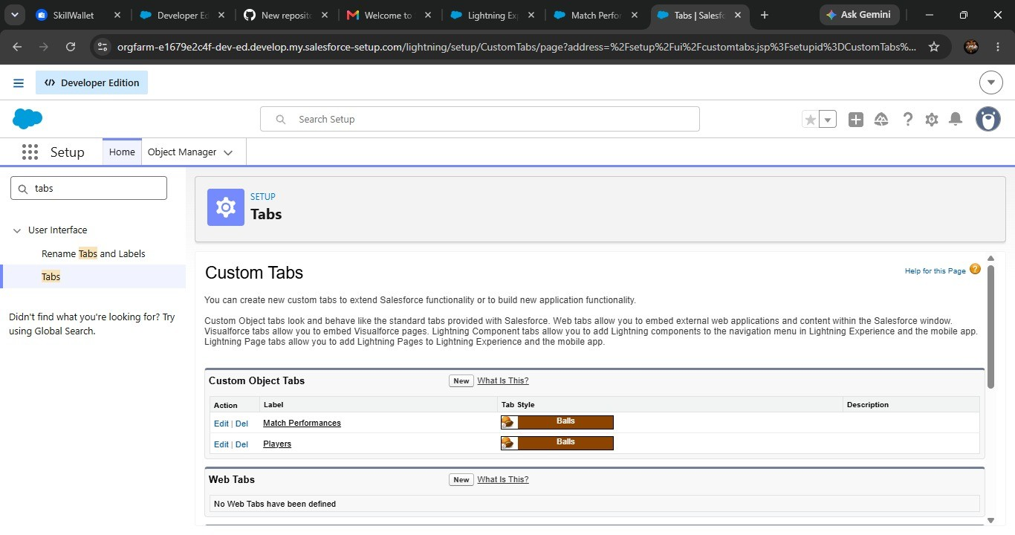

Milestone 4 - The Lightning App

Activity 1 : Create a lightning app

- Go to setup page → search “app manager” in quick find → select “app manager” → click on New lightning App.
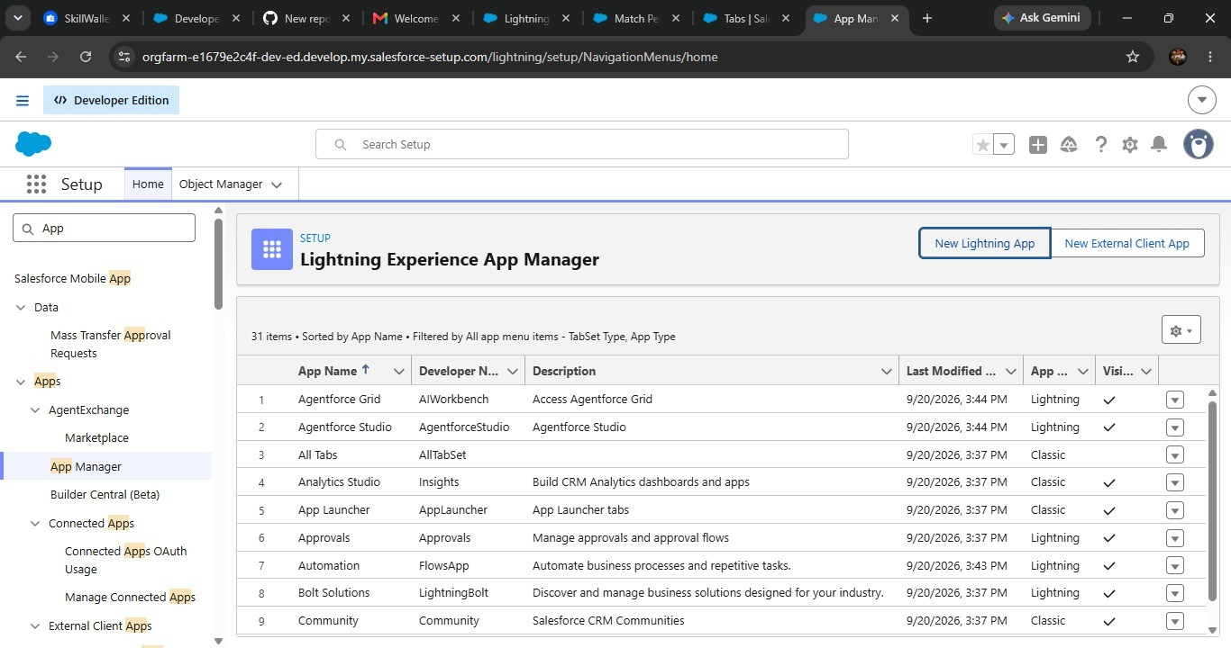

- Fill the app name in app details and branding as follow
App Name : CRICKSTATS
Developer Name : Auto Populates
Add image optional (if you want to give any image you can otherwise not mandatory) - Add Primary color Hex or leave it to default.
Then click Next.

- In App options
Navigation style : Standard navigation
Setup experience : setup
Supporters form factors : Desktop and phone
Then click Next
- In Utility items
Utility Bar alignment : Default Then click Next.
- Navigation items
Select the created Custom Objects and required standard objects
• Players
Match Performances
Reports
Dashboards
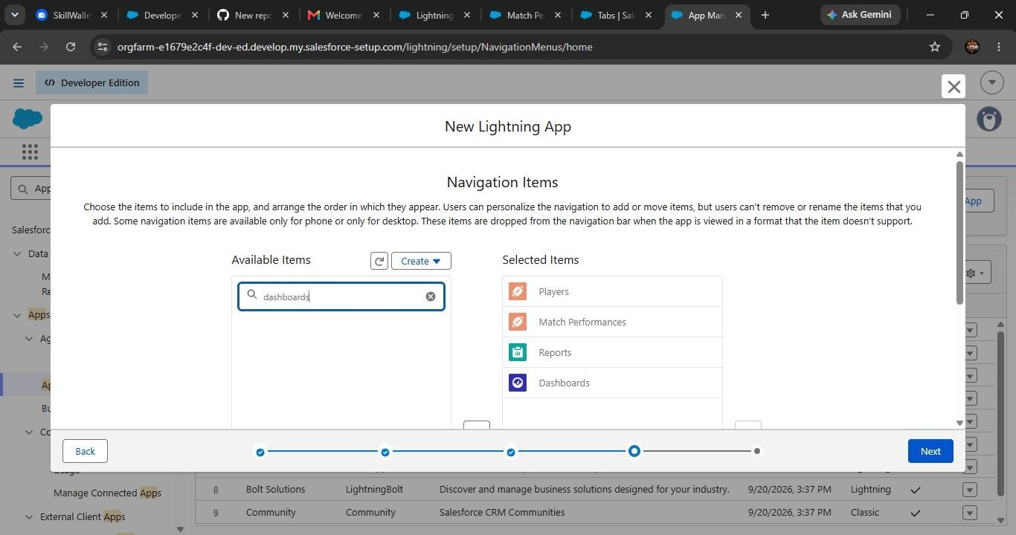

- To Add User Profiles : System Administrator
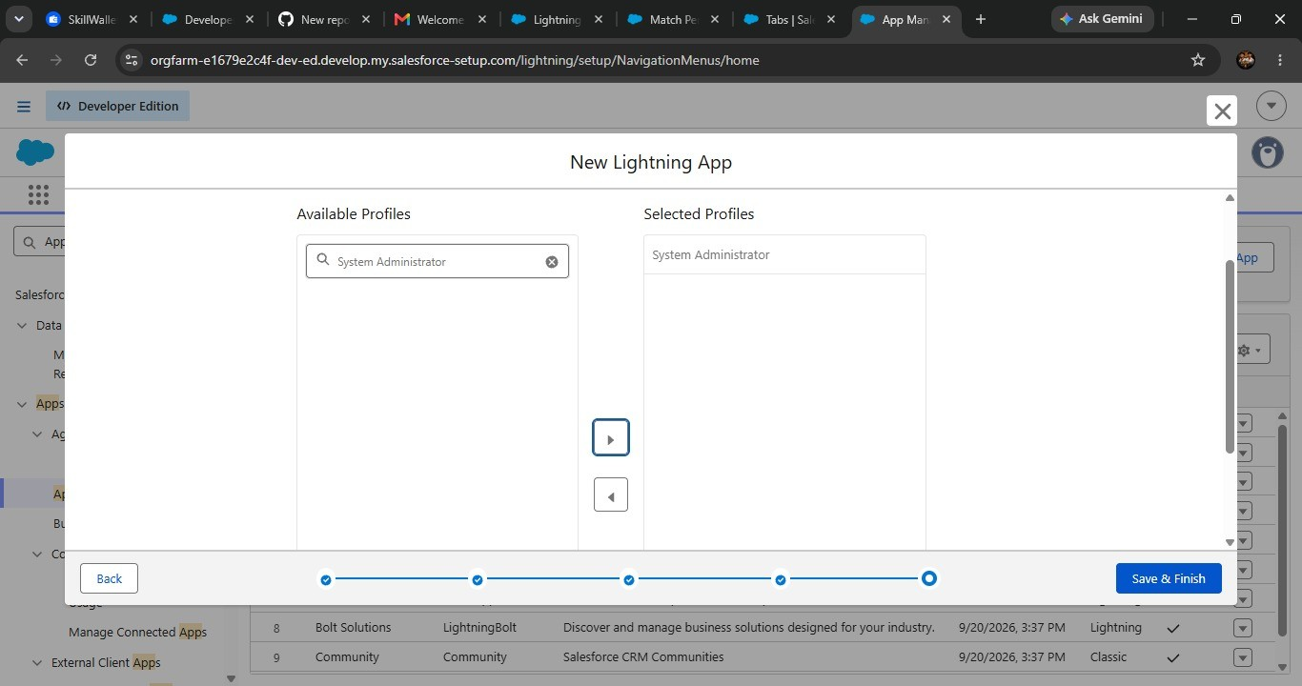

7.Click Save & Finish.

Milestone 5 : Fields & Relationships

Activity 1 : Create Custom fields for Player object
- In your Salesforce org, click gear icon on the top left and select Setup to open Setup
- Click the Object Manager tab. If you don’t see it, enter Object Manager in the Quick Find box
- From the object manager page, In the Quick Find box, Search for the custom object you just created : Player
- From the sidebar, click Fields & Relationships. Notice that there are already some fields there. Those are the standard fields.
- Click New to create a custom field. Tip: Before creating a new field, do a quick search to make sure a similar one doesn’t already exist.
- Next, choose a data type as Text. Choosing a data type helps you format the field input. 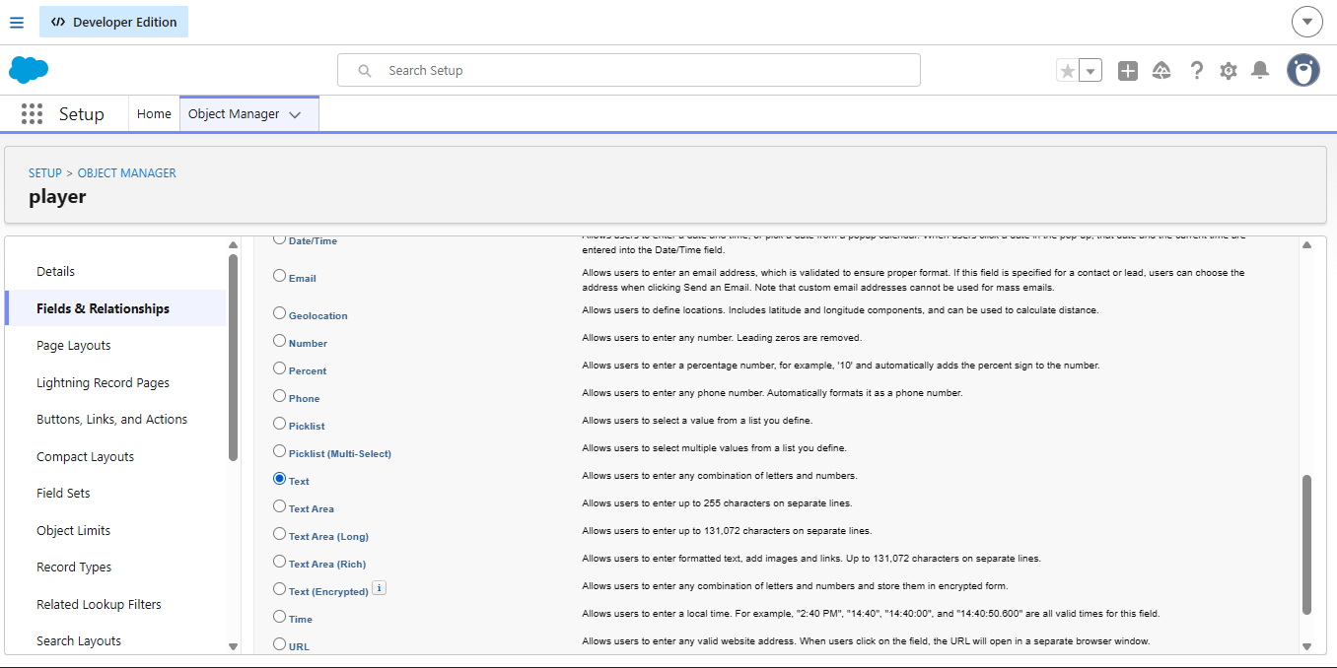
- Click on next.
- Data Type : Text
Field Label: Player Name
Field Name : Auto Populates
Field Label: Player Name
Length : 50
Click on Next → Next → Save and new.
- Repeat the Same steps for remaining fields
- Data Type : Text
Field Label: Player Number
Field Name : Auto Populates
Length : 3
Click on Next → Next → Save and new
- Data Type : Rich Text Area
Field Label : Profile Picture
Field Name : Auto Populates
Click on Next → Next → Save and new.
- Data Type : Date
Field Label : Date of Birth
Field Name : Auto Populates
Click on Next → Next → Save and new.
- Data Type : Picklist
Field Label : Role
Field Name : Auto Populates
Value : Enter value, with each value separated by a new line.
Batsman
Bowler
Batsman & Wicket Keeper
All Rounder
- Data Type : Picklist
Field Label : Batting Style
Field Name : Auto Populates
Value : Enter value, with each value separated by a new line.
Right- Handed
Left - Handed
Click on Next → Next → Save and new.
- Data Type : Picklist
Field Label : Bowling Style
Field Name : Auto Populates
Value : Enter value, with each value separated by a new line.
Right-Arm Fast
Left-Arm Fast
Right-Arm Medium
Left-Arm Medium
Right-Arm Spin
Left-Arm Spin
Click on Next → Next → Save and new.
- Data Type : Picklist
Field Label : Nationality
Field Name : Auto Populates
Value : Enter value, with each value separated by a new line.
Australia
Bangladesh
England
India
New Zealand
Pakistan
South Africa
Sri Lanka
West Indies
Afghanistan
Zimbabwe
Ireland
Scotland
Netherlands
United Arab Emirates
Nepal
United States of America
Click on Next → Next → Save and new.
- Data Type : Picklist
Field Label : Team
Field Name : Auto Populates
Value : Enter value, with each value separated by a new line
Chennai Super Kings (CSK)
Delhi Capitals (DC)
Kolkata Knight Riders (KKR)
Mumbai Indians (MI)
Punjab Kings (PBKS)
Rajasthan Royals (RR)
Royal Challengers Bangalore (RCB)
Sunrisers Hyderabad (SRH)
Gujarat Titans (GT)
Lucknow SuperGiants (LSG)
- Data Type : Formula
Field Label : AVG Score
Field Name : Auto Populates
Formula Return : Number
Formula : IF(
Matches_Played__c > 0,
Total_Runs__c / Matches_Played__c ,
0
)
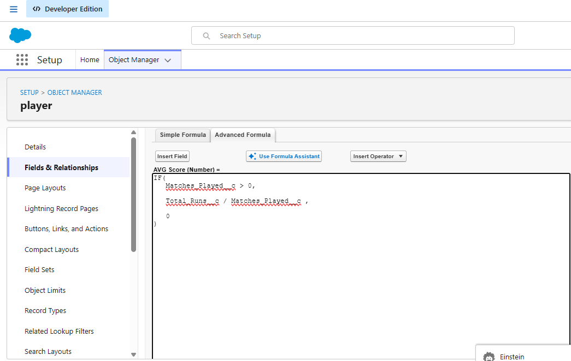
Click on Next → Next → Save & New.
- Data Type : Lookup Relationship
Related To : Match Performance
Field Label : Match Performance
Field Name : Auto Populates
Click on Next → Next → Save.

Activity 2 : Create Custom fields for Match Performance object
- Data Type : Text
Field Label: Match Performance Name
Field Name : Auto Populates
Length : 80
Click on Next → Next → Save and new.
- Data Type : Checkbox
Field Label: Player of the Match
Field Name : Auto Populates
Click on Next → Next → Save and new.
- Data Type : Picklist
Field Label: Match Result
Field Name : Auto Populates
Value : Enter value, with each value separated by a new line
WON LOST DRAW
Click on Next → Next → Save and new.
- Data Type : Number
Field Label: Runs Scored
Field Name : Auto Populates
Click on Next → Next → Save and new.
- Data Type : Number
Field Label: Balls Faced
Field Name : Auto Populates
Click on Next → Next → Save and new.
- Data Type : Number
Field Label: Fours
Field Name : Auto Populates
Click on Next → Next → Save and new.
- Data Type : Number
Field Label: Sixes
Field Name : Auto Populates
Click on Next → Next → Save and new.
- Data Type : Number
Field Label: Overs Bowled
Field Name : Auto Populates
Click on Next → Next → Save and new.
- Data Type : Number
Field Label: Wickets Taken
Field Name : Auto Populates
Click on Next → Next → Save and new.
- Data Type : Number
Field Label: Runs Conceded
Field Name : Auto Populates
Click on Next → Next → Save and new.
- Data Type : Number
Field Label: Maiden Overs
Field Name : Auto Populates
Click on Next → Next → Save and new.
- Data Type : Number
Field Label: Stumpings
Field Name : Auto Populates
Click on Next → Next → Save and new.
- Data Type : Number
Field Label: Catches
Field Name : Auto Populates
Click on Next → Next → Save and new.
- Data Type : Master - Detail Relationship
Related To : Player
Field Label : Player
Field Name : Auto Populates
Click on Next → Next → Save.

Milestone 6 : Roll-up Summary

Activity 1 : Create Roll-up Summary for Player object.

Note :- Roll-up Summary can only be created on parent object in Master- Detail Relationship.
- In your Salesforce org, click gear icon on the top left and select Setup to open Setup.
- Click the Object Manager tab. If you don’t see it, enter Object Manager in the Quick Find box.
- From the object manager page, In the Quick Find box, Search for the custom object you just created : Player
- From the sidebar, click Fields & Relationships. Notice that there are already some fields there. Those are the standard fields.
- Click New to create a custom field. Tip: Before creating a new field, do a quick search to make sure a similar one doesn’t already exist. Click Next,
- Choose a data type as Roll-up Summary. Click Next.
Field Label: Matches Played
Field Name : Auto Populates
Summarized Object : Match Performances
Select Roll-up Type : COUNT

Filter Criteria : All records should be included in the calculation. Click on Next → Next → Save and new.
- Data Type : Roll-up Summary
Field Label: Number of 50’s
Field Name : Auto Populates
Summarized Object : Match Performances
Select Roll-up Type : COUNT
Filter Criteria : Only records meeting certain criteria should be included in the calculation.
Click on Next → Next → Save and new.
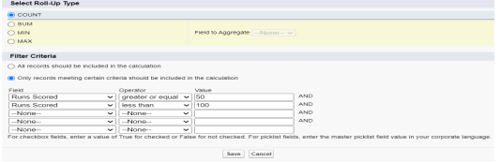

- Data Type : Roll-up Summary
Field Label: Number of 50’s
Field Name : Auto Populates
Summarized Object : Match Performances
Select Roll-up Type : COUNT
Filter Criteria : Only records meeting certain criteria should be included in the calculation.
Click on Next → Next → Save and new.
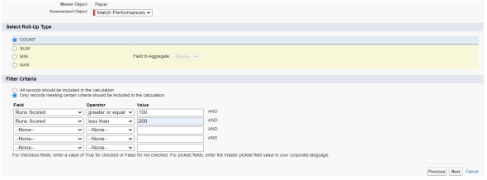

- Data Type : Roll-up Summary
Field Label: Total 4’s
Field Name : Auto Populates
Summarized Object : Match Performances
Select Roll-up Type : SUM
Field To Aggregate : Fours
Filter Criteria : All records should be included in the calculation.
Click on Next → Next → Save and new.
- Data Type : Roll-up Summary
Field Label: Total 6’s
Field Name : Auto Populates
Summarized Object : Match Performances
Select Roll-up Type : SUM
Field To Aggregate : Sixes
Filter Criteria : All records should be included in the calculation.
Click on Next → Next → Save and new.
- Data Type : Roll-up Summary
Field Label: Total Runs
Field Name : Auto Populates
Summarized Object : Match Performances
Select Roll-up Type : SUM
Field To Aggregate : Runs Scored
Filter Criteria : All records should be included in the calculation.
Click on Next → Next → Save and new.
- Data Type : Roll-up Summary
Field Label: Total Overs
Field Name : Auto Populates
Summarized Object : Match Performances
Select Roll-up Type : SUM
Field To Aggregate : Overs Bowled
Filter Criteria : All records should be included in the calculation.
Click on Next → Next → Save and new.
- Data Type : Roll-up Summary
Field Label: Total Wickets
Field Name : Auto Populates
Summarized Object : Match Performances
Select Roll-up Type : SUM
Field To Aggregate : Wickets Taken
Filter Criteria : All records should be included in the calculation.
Click on Next → Next → Save and new.
- Data Type : Roll-up Summary
Field Label: Total Stumpings
Field Name : Auto Populates
Summarized Object : Match Performances
Select Roll-up Type : SUM
Field To Aggregate : Stumpings
Filter Criteria : All records should be included in the calculation.
Click on Next → Next → Save and new.
- Data Type : Roll-up Summary
Field Label: Total Catches
Field Name : Auto Populates
Summarized Object : Match Performances
Select Roll-up Type : SUM
Field To Aggregate : Catches
Filter Criteria : All records should be included in the calculation.
Click on Next → Next → Save and new

Milestone 7 : Flows
- Go to setup, Type Flow in quick find box → Click on the Flow and Select the New Flow.
- Select Screen Flow and click Create.
- Click (+) Icon on the flow builder and Select Screen Component.
Label : Players screen
API : Players_screen
Select the Picklist component and place it on the screen.
Label : Team
API : Team
From Component Pane on the left side select Component Type : Picklist
Data Type : Text
Choice : Click New Choice Resources
Resource Type : Picklist Choice Set

API Name : Team
Object : Player
Data Type : Picklist
Field : Team
Click Done
- Click (+) Icon on the flow builder and Select Get Records Component.
Label : Players
API Name : Players
Object : Player
Filter player records :
Field : Team
Operator : Equals
Value : Click New Resource
Resource Type : Variable
API Name : Dynamic
Data Type : Text
Default Value : Screen component : Team (Picklist)
- Click (+) Icon on the flow builder and Select Screen Component.
Label : Player_info
API Name : Player_info
From Component Pane on the left side select Component Type : Data table
API Name : Player_info_table
Label : Data Table
Configure Data Source : Source Collection : Players from players (Player__c)
In Configure Columns : Add all the required Columns
Profile Picture | Player Name | Total Runs | AVG Score | Batting Style | Bowling Style | Matches Played | Number of 50’s | Number of 100’s Click Done
Click Save.
Flow Label : Player Flow Flow API Name : Player_Flow

Activity 2 : Flow on Home Page
- On your CRICKSTATS Application on the top right of the Navigation Bar click on Personalize your nav bar icon (Pencil Icon) and Add Home Page and click Save.
- Remove all other components and Add FLOW component from the standard components on the left side.
- Flow : Players Flow
- 4. Click Save and Activation.
- Click on App Default and select Assign to Apps.
- Select CRICKSTAS App and Click Next and then click Save

7. FUNCTIONAL & PERFORMANCE TESTING
The supplied document states that screenshots were captured from the Salesforce Lightning interface to verify the implemented features. Testing covered record creation, validation checks, record-type behavior for Domestic and International match categories, flow execution, data consistency, roll-up calculations, report generation, and dashboard loading.

7.1 Functional Test Areas
Test Area | Expected Result | Evidence/Check | Status
Player record creation | Player record can be created with required details | Record creation in Player object | Tested in project
Match Performance entry | Match statistics are stored correctly | Runs, wickets, catches, etc. | Tested in project
Validation | Invalid or incomplete values are restricted | Mandatory/input constraints | Tested in project
Roll-up summaries | Player totals update from child records | Runs, wickets, matches, etc. | Tested in project
Screen Flow | Selected team returns matching players | Filtered data table | Tested in project
Reports/Dashboards | Statistics are visualized correctly | Generated analytics | Tested in project

7.2 Performance Testing
The project also evaluates response time during data entry, report generation, and dashboard loading. The original requirements specify quick response and provide an example target of 2–3 seconds for a performance report covering 100+ players. This should be treated as a project requirement/example rather than a measured benchmark unless an actual timing record is available.

7.3 Test Data
The source document notes that records should be entered in the Player and Match Performance objects to obtain results. Therefore, meaningful roll-up and flow outputs depend on having sample player and match-performance records.

8. RESULTS & DISCUSSION
The implemented design provides a centralized structure for storing cricket player information and match-level statistics. The relationship model allows individual performances to contribute to player-level summaries. The screen flow adds a user-friendly way to filter players by team and view important performance fields.

8.1 Expected System Output
- Player profiles can be maintained in a single Salesforce environment.
- Match performances can be associated with players.
- Cumulative totals can be derived using roll-up summaries.
- Average score can be calculated from total runs and matches played.
- Users can select a team and view relevant player records through the flow.
- Reports and dashboards can present analytical views of stored statistics.

8.2 Student Learning Outcomes
- Understanding Salesforce custom-object creation.
- Understanding field types and relationships.
- Practical use of Master-Detail and Lookup relationships.
- Creating roll-up summaries and formula fields.
- Building Salesforce Screen Flows.
- Configuring Lightning applications and navigation.
- Planning work using Agile-style sprints and user stories.
- Performing functional and basic performance testing.

9. ADVANTAGES & DISADVANTAGES
Advantages | Disadvantages
Centralized system | Requires Salesforce license
Real-time analytics | Internet dependency
Secure platform | Limited offline access
Scalable design
Reduced manual work

10. CONCLUSION
CRICKSTATS successfully demonstrates a Salesforce-based approach to cricket player performance tracking. The project combines structured data storage, relationships, roll-up calculations, formula-based analysis, Lightning application design, and flow automation. These components provide a foundation for recording match information and converting it into player-level performance insights.

From a student-project perspective, CRICKSTATS demonstrates how a CRM platform can be configured for a domainspecific information system. It also connects requirements analysis, system design, implementation, testing, and project planning into a single development workflow

. 11.FUTURE SCOPE
- Mobile application integration.
- AI-based performance prediction.
- Video analysis integration.
- Player ranking system. • Public statistics portal.
- Multi-league support.

These future-scope items are taken directly from the supplied project document. Implementing them would require additional design, data, integration, and validation work.

12. APPENDIX

12.1 Main Salesforce Components
Component | Purpose | Examples
Object | Store structured records | Player, Match Performance
Relationship | Connect records | Master-Detail, Lookup
Formula | Calculate derived values | AVG Score
Roll-up Summary | Aggregate child records | Total Runs, Total Wickets
Flow | Guide/automate user interaction | Player Flow
Lightning App | Provide application navigation | CRICKSTATS
Reports & Dashboards | Analyze and visualize information | Performance analytics

12.2 Suggested Demonstration Sequence
- Open the CRICKSTATS Lightning App.
- Create or view a Player record.
- Create Match Performance records for the player.
- Verify that roll-up totals reflect the related records.
- Open the Player Flow from the home page.
- Select a team from the Team picklist. • Review the filtered player data table.
- Open reports/dashboards to analyze the stored statistics.

Thank you

